1st June
Phonics worksheet, week 6

‘ear’ sounds – can you fill in the missing words?

When we cry we shed a _ _ _ _

Did you _ _ _ _ me? 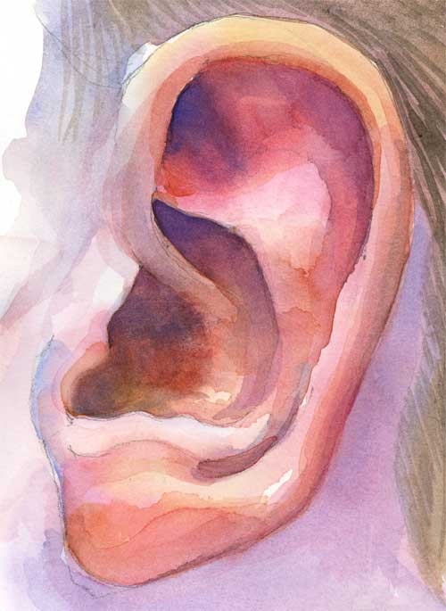

Happy New _ _ _ _! 

Does your dad have a _ _ _ _ _?

Do you have a bike with _ _ _ _ _?

beard gears tear

hear year

