P.E.

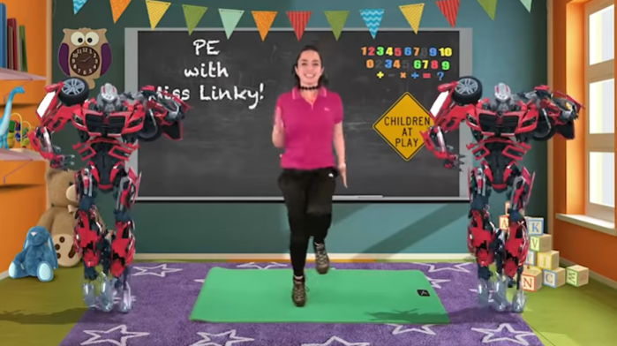

Enjoy a super hero workout here with Miss Linky.
https://www.youtube.com/watch?v=VMj2ZgQqsNA

