Week 4
11th May

Hello everybody
Have you had a good week? Thank you to all of you who have been sharing your work with us.
I’m really enjoying Mr Mc’s phonics lessons. Are you?
I have read you a story by Shirley Hughes this week, called Shop. It comes from The Big Alfie Outdoors Storybook. You can listen to the story on our youtube channel https://www.youtube.com/watch?v=8uYVdDYM9NE
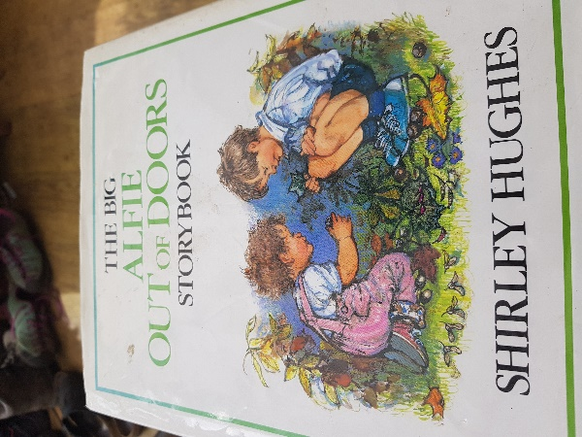
In this story Alfie and his little sister build a shop in their garden out of a big cardboard box. They pretend to sell lots of things to their Mum and Grandma.
Have you ever made anything out of boxes? Maybe you could pretend to have a shop in your house or garden. If you do, don’t forget to tweet or email us some pictures.

Love from
Mrs Ceuppens, Mrs Sherratt and Ms Parrin

Here are some more ideas in a story called ‘Not a Box’. https://www.youtube.com/watch?v=qXqFv610g0o

