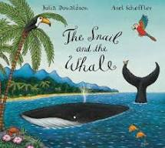

Maths
Click on the link below which will take you to the White Rose Maths website. Then click on week 6 to access daily maths learning activities, which will help you to practise concepts and skills that we have already learned.
https://whiterosemaths.com/homelearning/early-years/

Remember to keep practising your counting by twos
https://www.youtube.com/watch?v=JyCr0IgbYcI
and fives
https://www.youtube.com/watch?v=cJ4jV14Oz5I

Have fun!

