The Snail
By Henry Matisse

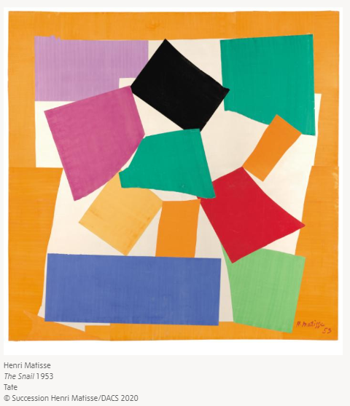

https://www.tate.org.uk/kids/explore/who-is/who-henri-matisse

Henri Émile Benoît Matisse 31 December 1869 – 3 November 1954) was a French artist, known for his use of bright colours in his paintings.
As he grew older his ill health meant he couldn’t paint anymore ant this made Matisse feel really sad. As he still wanted to create great art, he decided to use scissors to cut brightly coloured paper and to use the paper to make paper collage. He called this painting with scissors.
https://www.tate.org.uk/tate-etc/issue-30-spring-2014/his-brilliant-final-chapter here are some of his collages.

Why don’t you have a go at making a bright collage picture?
https://www.tate.org.uk/kids/make/cut-paste/collage-matisse-snail

