Week 6
1st June 2020
Hello everybody
Have you had a good half term? The weather has been lovely and I have been in my garden and going on walks with my dog. The vegetables I planted are all growing.
I have also been looking out for birds. I have seen a wren, a bluetit, a robin, a sparrow and a baby blackbird. The blackbird is very friendly and likes to hop near us when we are sitting outside.
What have you been doing? Have you noticed any birds in your garden?
It would be lovely to hear your news.
This week Mrs Sherratt has given you some maths to do based on the book The Snail and the Whale by Julia Donaldson.
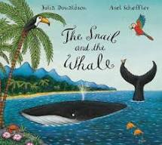
You can listen to the story if you click on the link below.
https://www.youtube.com/watch?v=EmMnaSkeKqQ
The author is Julia Donaldson. Can you remember any of the other stories she has written?

Here you can find some more stories about snails
Snail Trail
https://www.youtube.com/watch?v=XsCgl6DobN4
Matisse’s Magical Trail by Tim Hopgood & Sam Boughton
https://www.youtube.com/watch?v=G5U6jq8OpcI
Are you a snail?
https://www.youtube.com/watch?v=_H5PiUuAPv4

Have fun
Love from
Mrs Ceuppens, Mrs Sherratt and Miss Parrin

