Year 2 home learning week commencing 20 April 2020

Maths Answers in red

We are going to start this half term by learning about properties of shapes.

Go through Maths PowerPoint 1. Make sure you click to hear my explanations!

Activity 1

You can write your answers in your books or on paper.

- Write the name of each shape in the PowerPoint and say how many sides and vertices it has:

Picture | Name of shape | Sides | Vertices
 | Circle | 1 | 0
 | Rectangle | 4 | 4
 | Square | 4 | 4
 | Triangle | 3 | 3

- I am thinking of a shape. It has 4 sides and 4 vertices. The sides are not the same length. What could it be?

A rectangle

- Which shape is the odd one out? Explain your answer. 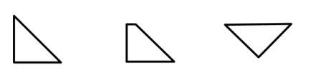
The middle one because it has 4 sides and 4 vertices and the other two shapes have 3 sides and 3 vertices. The middle shape is the only one which is not a triangle.

Activity 2

- Write a list of all the shapes used to make this picture.

e.g. 7 circles

7 circles, 4 squares, 4 rectangles and 1 triangle

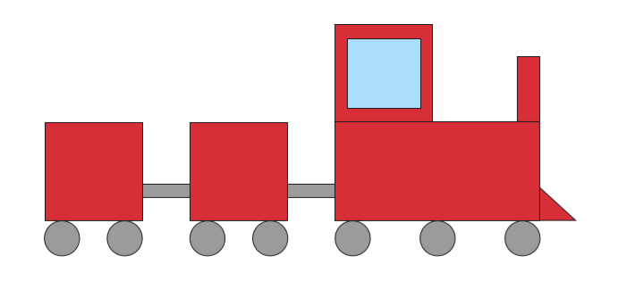

- Draw a different picture made out of just squares, triangles, rectangles and circles.

You could do any picture made of these shapes. Here’s an example!
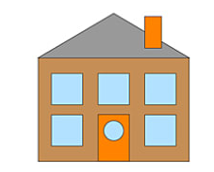

- Miss Coope is making triangles using lolly sticks. She uses one lolly stick for each side.

She says ‘I need 3 lolly sticks to make each triangle’.
Is she right or wrong?

She is right because a triangle has 3 sides.

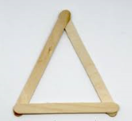

How many lolly sticks does she need to make 4 triangles? 12

How many triangles can she make with 15 lolly sticks? 5

