Week 2 (WC 27th April)

Maths :- We will be looking at the 3 times tables.

Look at PowerPoint 2

Activity sheet 1:

Question 1
Read the question and show your answer by writing two multiplication calculations.

There are twelve tricycles outside the school.

- How many wheels are there?

ANSWER: - There are 36 wheels.

12 x 3 = 36 12 tricycles with 3 wheels on each.

3 x 12= 36 3 wheels on 12 tricycles.

Question 2
Read the question and show your answer by drawing out groups of three, just like I did with the juice cartons in the PowerPoints.
Use practical apparatus to make groups of three if you need to (eg bits of pasta or Lego bricks)
Have a go at writing a multiplication/addition calculation to show the extra group.

There are twelve tricycles outside the school.

- How many wheels would there be altogether if another tricycle arrived?

12 x 3 + 3 = 39 there would be 39 wheels if another tricycle arrived.

Question 3
Read the question and show your answer by drawing out groups of three, just like I did with the juice cartons in the PowerPoints.
Use practical apparatus to make groups of three if you need to (eg bits of pasta or Lego bricks)
Can you write a multiplication/subtraction calculation to show what you have done?

I had eight rows of three cupcakes but I ate one row.

- How many cupcakes are left?

8 x 3 – 3 = 21 There are 21 cupcakes left.

Activity sheet 2:

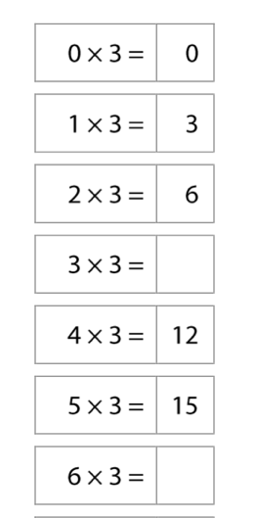
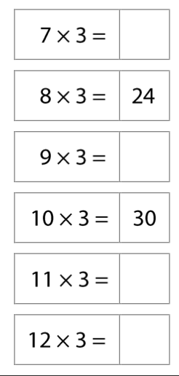
Question 1
21

27

9

33

36
18

Question 2

27
12

9
4

9
4

Question 3
Read the question and use practical apparatus (eg pasta or Lego bricks) to share between three groups if you need to.
Show your answer by drawing out your groups.
Use your drawing to write a division calculation and show your final answer.

Three children share twenty-four stickers between them.
How many stickers does each child have?

24 stickers divided by 3 children = 8
Each child will have 8 stickers.

Each child is then given one more sticker.
How many stickers does each child have now?
Record your answer using written calculations.

Each child has 8 stickers.
8 + 1 = 9
8 + 1 = 9 OR 24 ÷ 3 +3 = 27
8 + 1 = 9 27 ÷ 3 = 9
Each child now has 9 stickers.

Question 4 - Challenge

If £54 is divided equally between three children, they each receive £18 pounds.
How much money would they have altogether if they had received £19 each instead?

54 ÷ 3 = 18

57 ÷ 3 = 19

They would have had £57 to start with

Additional maths activities: -

Create a poster with 3 times table.

Continue to practice your times tables on Times table Rockstars.

