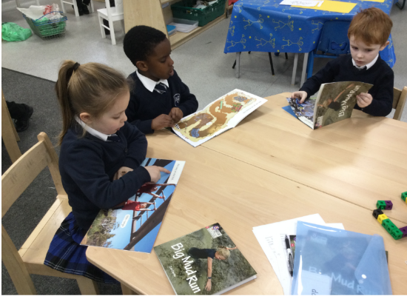
At Ash Grove Academy we believe that for all our children to become fluent readers and writers, phonics must be taught through a systematic and structured phonics programme.

We use the Little Wandle Letters and Sounds Revised to plan and provide daily engaging phonics lessons. In phonics, we teach children that the letters of the alphabet represent a different sound, that these can be used in a variety of combinations and are put together to make words. The children learn to recognise all of the different sounds and combinations that they might see when they are reading or writing. Our phonics teaching starts in Nursery and follows a very specific sequence that allows our children to build on their previous phonic knowledge and master specific phonic strategies as they move through school. As a result, all our children are able to tackle any unfamiliar words that they might discover. At Ash Grove we also model these strategies in shared reading and writing both inside and outside of the phonics lesson and across the curriculum. We have a strong focus on the development of language skills for our children because we know that speaking and listening are crucial skills for reading and writing in all subjects.
How we teach phonics
- In the nursery, children follow the Little Wandle Letters and Sounds Revised ‘Foundations for Phonics’ guidance. The focus is on daily oral/aural blending and language development through high quality stories and rhymes.
- In Reception and Year 1, children follow the progression within Little Wandle Letters and Sounds Revised programme. Phonics is taught daily and there is a review session on a Friday.
- Phonics starts in Reception in week 2 to ensure the children make a strong start.
- By the end of Reception, children will have been taught up to the end of Phase 4.
- By the end of Year 1, children will have been taught up to the end of Phase 5.
- Reception lessons start at 10 minutes, with daily additional oral blending – increasing to 30 minutes as soon as possible.
- Year 1 lessons are 30 minutes long.
- In Year 2 - Year 3, phonic lessons are taught daily to children where appropriate – following the model of Little Wandle but plugging specific gaps identified through assessment.
- In Y2-Y6 there are planned phonic ‘catch-up’ sessions following a set model to address specific reading/writing gaps. These are short, sharp sessions lasting 10 minutes in length and taking place at least three times a week.
Reading practice sessions
- Children across Reception, Year 1, Year 2 (and beyond if appropriate) apply their phonics knowledge by using a full matched decodable reader in a small group reading practice session.
- These sessions are 15 minutes long and happen three times a week. There are approximately 6 children in a group.
- The sessions follow the model set out in Little Wandle Letters and Sounds Revised.
- The children are then allocated the same book as an ebook to read at home to ensure fluency, build expression and ensure success is shared with their family.
- In Reception these sessions start in week 4. Children who are not decoding do a little blending lesson, following the model set out in Little Wandle Letters and Sound Revised.
How do we assess phonic knowledge?
- In Reception and Year 1, at the end of each week, there is a review session which recaps the learning. There are also whole review weeks (pre-planned and bespoke review weeks to address gaps identified by the class teacher’s ongoing formative assessment).
- Children identified in Reception and Year 1 as in danger of falling behind are immediately identified and daily ‘keep up’ sessions are put in place – sessions follow the Little Wandle Letters and Sounds Revised programme.
- In Reception and Year 1, the children are assessed at the end of every half term using the Little Wandle Letters and Sounds Revised assessment tracker.
- The children in Year 1 sit the statutory Phonics Screening Check in the summer term.
- Children who do not pass the Phonics Screening Check in Y1 will re-sit this in Year 2.
- Children who are in Year 2-Year 6 and need ‘catch up’ sessions are assessed through teacher’s ongoing formative assessment as well as half termly summative assessments.
If you are a parent and would like more information about how to support your child with phonics at home, please follow this link to find the Reception and Year 1 overview as well as videos of the sound pronunciations, letter formation sheets and other helpful resources.
https://www.littlewandlelettersandsounds.org.uk/resources/for-parents/


